Tips for Installation and Maintenance
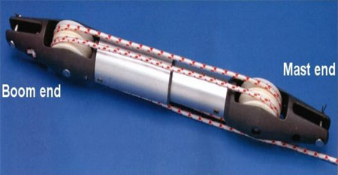
- The optimum angle for your U.S. Spars vang to be effective is 30*. This angle is governed by the position of the mast & boom fitting. U.S. Spars can calculate the exact position of the boom if you complete the form here.
- The mast attachment is best located as close to the deck as possible. We recommend 80mm above the deck to the underside of your bracket.
- Your U.S. Spars vang will come to you overlong (if you have a production boat and the length is known your vang will be the correct length) and may need to be shortened to achieve the correct boom support. Shortening the boom can be simply done by reducing the length of the inner or smaller tube by pulling the tubes apart and cutting the inner tube.
- Fit the vang to the mast and boom fittings, large tube to the boom. Leave the boom fitting loose in the track and use the boom topping lift to raise the boom to the appropriate height to install the rigid vang.
- With the sail installed, release the topping lift and with no tension on the vang line measure the boom angle. You may need to move the vang boom fitting aft to lower the boom and keep in mind the optimal 30* angle.
- Once you are happy that your vang is supporting the boom above the horizontal. Pull the boom down using the mainsheet until it grounds out. This is the maximum compression of the vang and the boom should now be 4* under horizontal. If the vang grounds out before the boom is under horizontal then the vang is too long and damage could occur if used.
- If needed, shorten the vang as required.
- Once the vang is the appropriate length, put the boom fitting into place. We recommend using a temporary fitting to ensure that everything has been done properly and then test the fitting under normal sailing conditions before final positioning.
- The vang comes with it's own 4-1 purchase installed. The rope must exit the final sheave at the boom end and run back to the base of the mast. Use a base block to run the vang line aft to the cockpit.
- When the boat is at rest in it's berth attach the boom lift and release pressure from the vang.
- If you have any questions regarding the installation of your U.S. Spars vang please contact the technical department at 386-462-3760. U.S. Spars can hold no responsibility for an incorrectly installed vang and the subsequent damage it may cause.

